Instructions for Organizers

Introduction

Overview
The DataStorm problem statement is great for shorter events with participants that are new to MATLAB. It provides them with a weather dataset and challenges them with 10 data extraction and analysis problems. We suggest you familiarize yourself with the problems and potential solutions ahead of time, as participants may have questions.

Audience and Event Timing
We recommend the following time allotment for this event:
- 1-2 hours for an audience that may have experience with coding or MATLAB
- 2-3 hours for participants that are brand new to coding and MATLAB.

The Dataset
This problem statement uses a dataset consisting of climate data from 2000-2010. The dataset has 6 parameters:
- AirTemperature – degree celcius
- RainfallFlux - mm/day
- SnowfallFlux - mm/day
- SpecificHumidity - g/kg
- SurfAirPressure - hPa
- WindSpeed - m/s
Each parameter is stored as an 11x365 matrix, with the rows representing the years, the columns representing the days, and the value at each (row,column) pair representing the measured data at that day on that year.
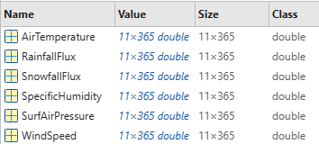

Interested in using this problem statement?
Reach out to hackathon@mathworks.com for access to the template materials in MATLAB Grader. You will need to meet the requirements for using MATLAB Grader:
- https://www.mathworks.com/help/matlabgrader/ug/prerequisites-for-instructors.html

Setup
Once you have access:
- Go to https://grader.mathworks.com/courses/167296
- Click on ‘Actions’ > ‘Copy’ on the right-hand corner
  - 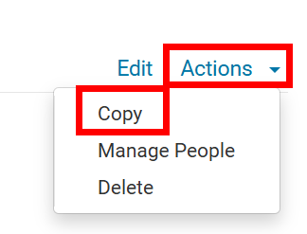
- Click ‘Copy’ on the pop-up to create your own copy of this course, which should be called ‘Copy of TEMPLATE: DataStorm Challenge’ by default. This will open a new tab where you should do the following steps.
- Name your event
- Set the time zone
- Set the start and end dates
- Click ‘Save’

Adding participants
Right before the event starts, you will need to add all participants to the MATLAB Grader course.
- Go to grader.mathworks.com and click on the course you created earlier
- Click on 'Manage People’ on the left menu
  - 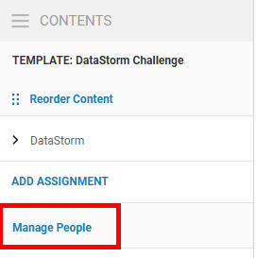
- In the page that opens, select ‘Learner’ in the drop down to enroll learners, then copy and paste all participants’ emails. You can do these all at once.
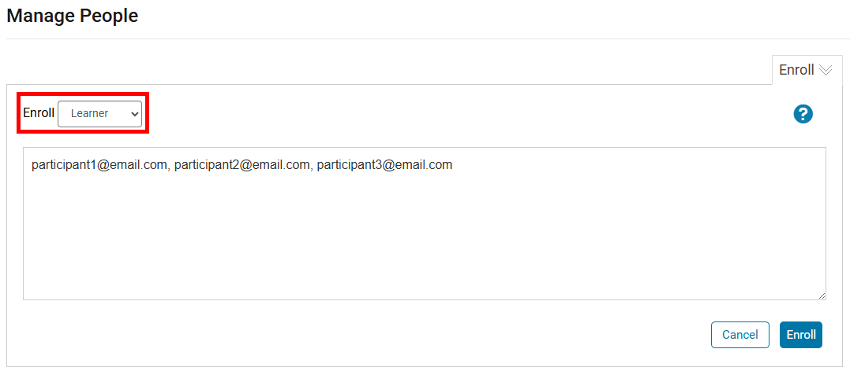
If you are using Devpost, follow these instructions for getting a list of participant emails. During the welcome presentation, you should tell participants to come up to you if they have not been added.

Evaluating
To export the results, click on the tab that says ‘DataStorm’:
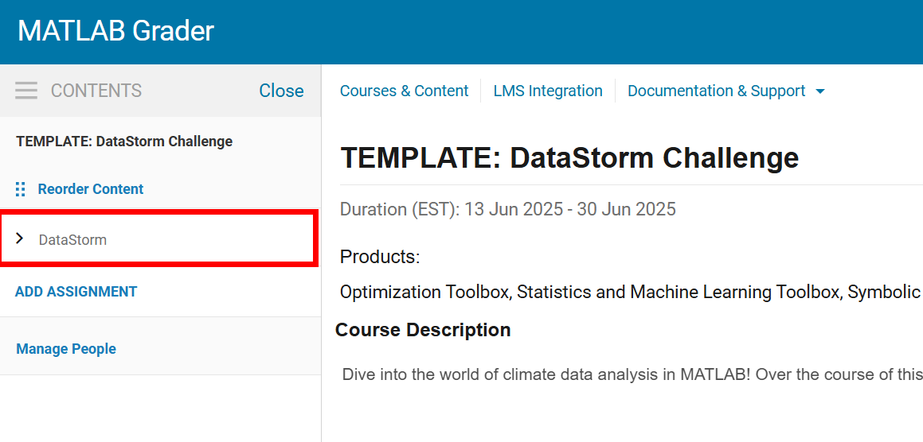Then click on ‘Actions’ > ‘Report’ in the top-right corner
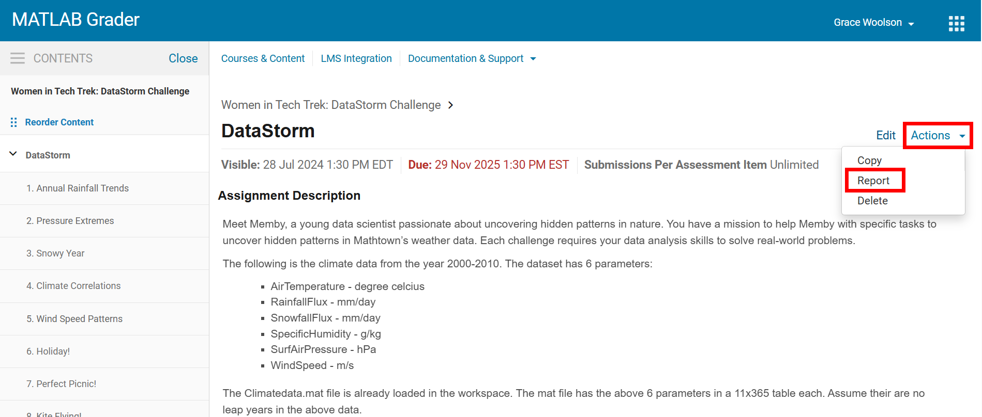On the popup that opens, choose to export the Best Solutions as of the due date as a CSV, then click ‘Report’. This should download a .CSV file called ‘DataStorm’.
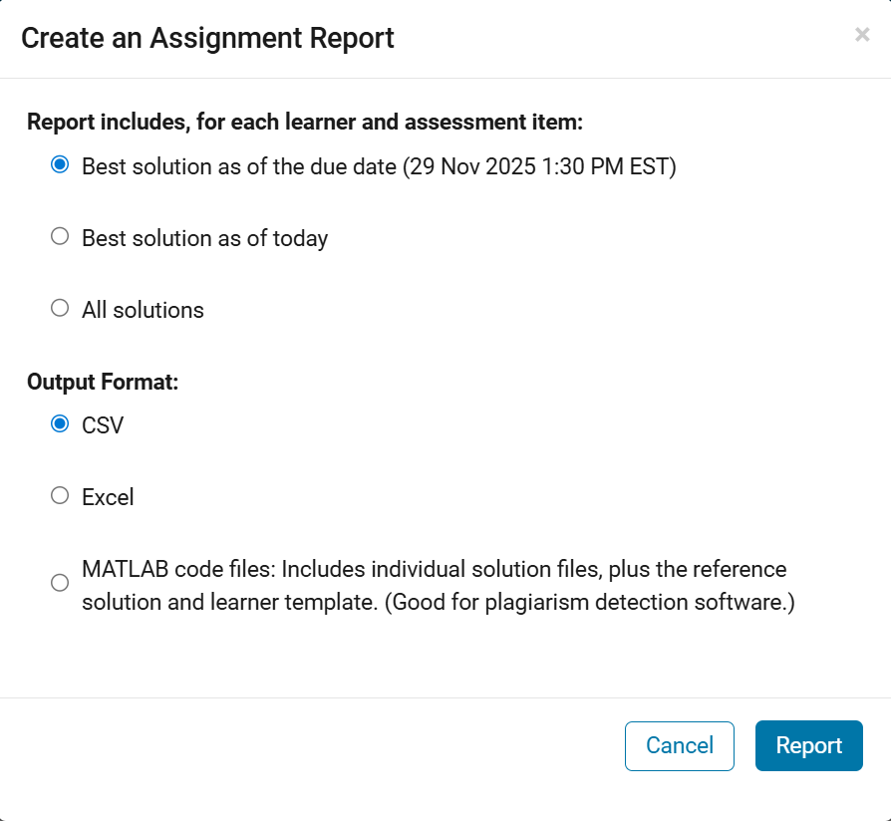
Use this file with the MATLAB Live Script ‘datastormAutoGrading.mlx’ to determine the winners:
- Open MATLAB
- Open ‘datastormAutoGrading.mlx’
- Update the fileLocation to be the file path of the results (ex: C:\Users\gracew\Downloads\DataStorm.csv)
- Run the live script by clicking on the ‘Run’ Button
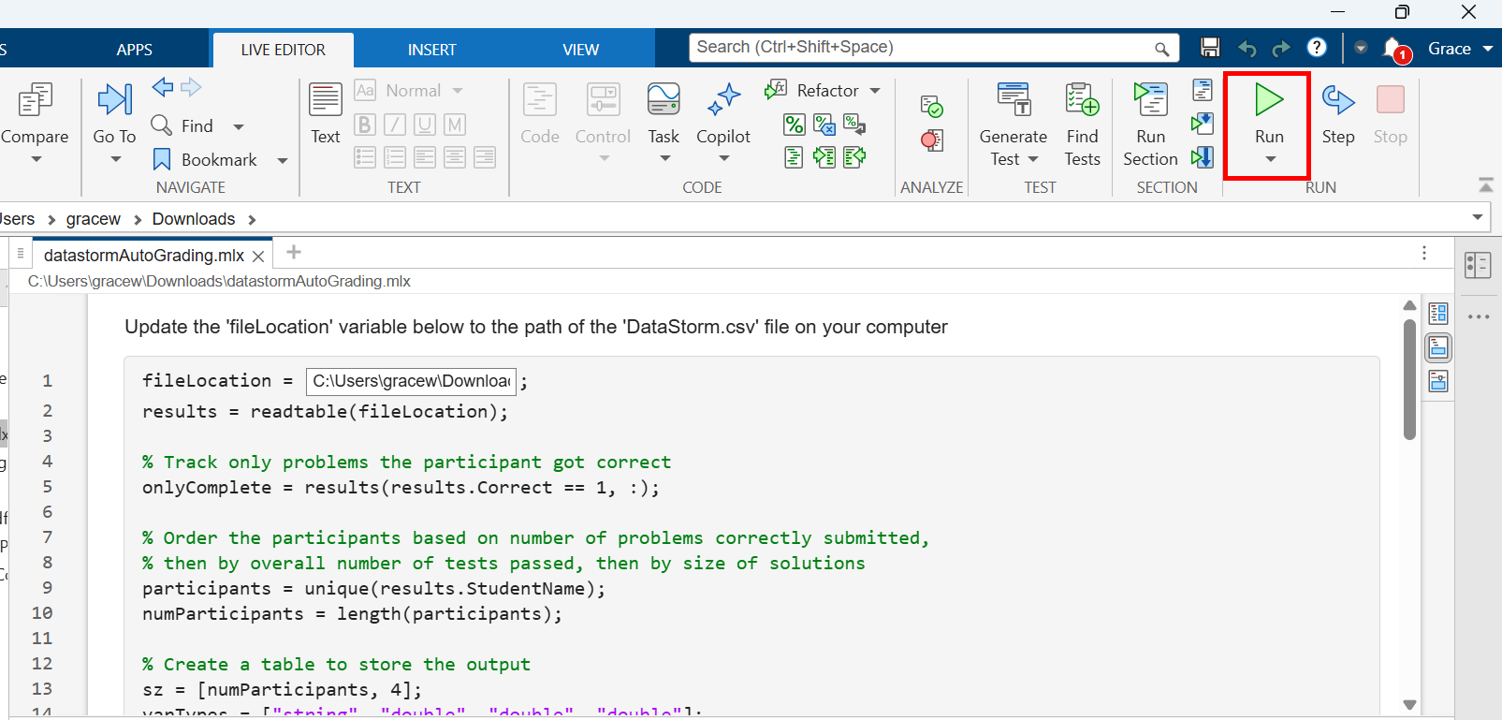
- Scroll to the bottom and use the output to determine the winning participants/teams. This should be the first, second, and third rows of the table.

